# Plasimo Display Assistant User Guide

Junming Zhang

July 15, 2017

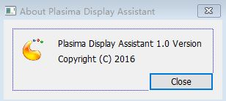

## Introduction

## Installing and Running

## The Graphical User Interface